Q 1) . Create the following tables with the given structures and insert sample data as specified: -

A) SALESPEOPLE:-

Snum int(4) ,Sname varchar(10), City varchar(10), Comm float(3,2)

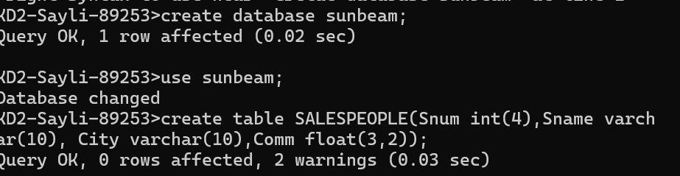

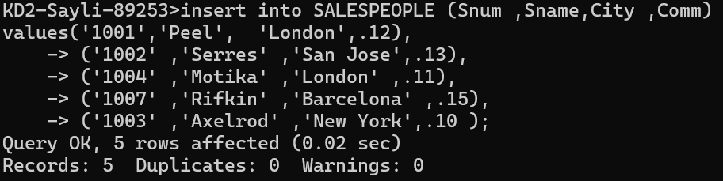

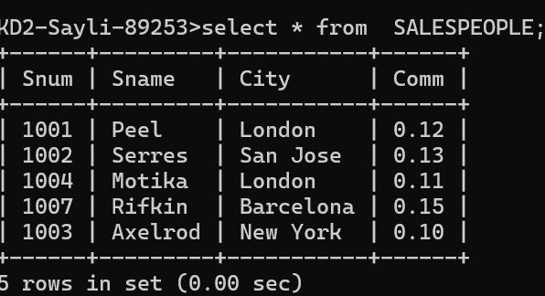

B) CUSTOMERS ;-

Cnum int(4), Cname varchar(10) ,City varchar(10), Rating int(4), Snum int(4)



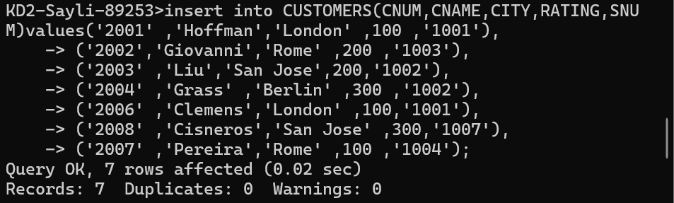

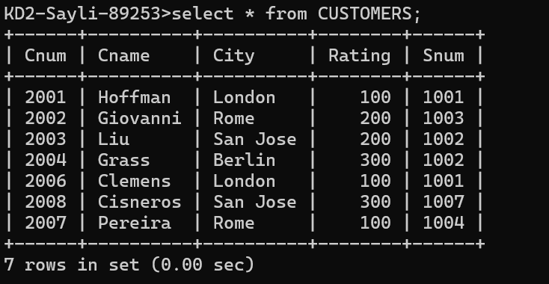

C) ORDERS:-

Onum int(4) ,Amt float(7,2), Odate date, Cnum int(4), Snum int(4)



